**Scenario 1:**

**Scenario name: Select categories**

**User Name: Lukas**

**Participant actor instances: Voter**

The flow of events:

1. Lukas wants to view the categories for voting.
2. Lukas open the application and view the home screen.
3. Lukas clicks vote button.
4. Lukas can see the categories and he can select any categories.
5. Lukas clicks any categories and if he wants to vote.

**Scenario 1 Extensions:**

1. Lukas can see all categories but if he was not log-in, he cannot vote for election that created by any registered user.

**Scenario 2:**

**Scenario name: View categories**

**User Name: Andrea**

**Participant actor instances: Voter**

The flow of events:

1. Andrea wants to view categories.
2. Andrea opens the applications.
3. Andrea view the home page of the application.
4. Andrea clicks the vote button.
5. Andrea can view the categories and if he wants to open any categories, he can click any categories.
6. If Andrea wants to back home page, he can click the back symbol on the screen.

**Scenario 3:**

**Scenario name: Apply an election**

**User Name: Nathan**

**Participant actor instances: Registered user, Admin of the application**

The flow of events:

1. Nathan wants to apply for an election.
2. Nathan opens the application and view the home page.
3. Nathan clicks the apply for election button.
4. Nathan view the blanks about election information.
5. Nathan has to fill all blanks.
6. Nathan fills these blanks: election question and election answers.
7. Nathan clicks the apply button.
8. If admin approve the elections, election will be publishing by the admin.

**Scenario 3 Extensions:**

1. If Nathan has not logged in and he clicks the apply for election button, he views the alert message like: “If you want to apply for an election, you have to log in.”
2. If Nathan has not filled the blanks correctly, when he clicks the apply button, he will be viewing an alert message like: “You have to fill all blanks correctly”.
3. When Nathan clicked apply button after the fill to all blanks, Nathan will be viewing a notification like: “You have applied successfully.”

**Scenario 4:**

**Scenario name: Delete an election**

**User Name: Broke**

**Participant actor instances: Admin of the application, Registered user (Apply for the election)**

The flow of events:

1. Broke wants to delete an election from the application.
2. Broke opens the application.
3. Broke views the home page and clicks the menu button on the screen.
4. Broke clicks to my published elections.
5. Broke views her own published elections.
6. If Broke wants to delete any election, she can click the “x” symbol and she can delete it.
7. In addition, Admin wants to delete any election from the application, he can click “x” symbol and he can delete it.

**Scenario 3 Extensions:**

1. When Brooke has deleted an election from her own published elections, she will be viewing a notification like: “You have deleted an election successfully!”.
2. If Broke has not logged in and she wants to menu button, she views just log-in/ register symbol so, she has to log-in for this process.

**Scenario 5:**

**Scenario name: Add an election**

**User Name: Peyton**

**Participant actor instances: Admin of the application (WEB)**

The flow of events:

1. Peyton wants to add an election.
2. Peyton opens the admin panel in web.
3. Peyton is logging in as admin.
4. Peyton fill the blanks about election.
5. Peyton clicks add election button.

**Scenario 3 Extensions:**

1. When Peyton add any election, all of users can see these elections and everybody can vote for these elections.
2. Peyton should add the elections with separate to the categories.

**Scenario 6:**

**Scenario name: View my published elections**

**User Name: Haley**

**Participant actor instances: Registered user**

The flow of events:

1. Haley wants to view own published elections.
2. Haley opens the applications.
3. Haley logs-in to the application.
4. Haley views home page of the application as a registered user.
5. Haley clicks menu button.
6. Haley selects my published elections.
7. Haley can view own published elections.

**USE CASE 1:**

|  |
| --- |
| Use Case Name: Select Categories |
| Participant Actor: Initiated by Voter |
| Flow of Events:  1. Voter sends a request to the system for select a category on the screen.  2. System first finds voter whether, he/she is log-in or not. Then, system lists the categories and voter selects a category that wants to select, and system displays it. |
| Entry Condition:  1. Voter has opened into the application.  2. Voter has selected categories from the categories screen. |
| Exit Condition:  1. Voter has selected any category and he/she has voted. OR,  2. Voter has selected any category and he/she has backed home page. |

**USE CASE 2:**

|  |
| --- |
| Use Case Name: View Categories |
| Participant Actor: Voter |
| Flow of Events:  1. Voter has opened into home page and he/she could be log in or not.  2.Voter has clicked “voting” button and viewed categories. |
| Entry Condition:  1. Voter may logged-in or not to system. |
| Exit Condition:  1. Voter has viewed categories and clicked back button. |

**USE CASE 3:**

|  |
| --- |
| Use Case Name: Apply an Election |
| Participant Actor: Registered user, Admin of the application |
| Flow of Events:  1. Registered user or admin has opened application and viewed home page.  2. Registered user or admin has clicked “Apply for election” button and fill blanks with about election. |
| Entry Condition:  1. Register user or admin must logged-in to system.  2. Registered user or admin must fill all blanks. |
| Exit Condition:  1. Registered user or admin has clicked “Apply” button and he/she has applied an election.  2. Registered user or admin has viewed apply election page and blanks and he/she may clicked “back” button. |

**USE CASE 4:**

|  |
| --- |
| Use Case Name: Delete an Election |
| Participant Actor: Admin of the application, Registered user (Apply for the election) |
| Flow of Events:  1. Registered user has opened application and logged in to system.  2. Registered user has clicked menu button and clicked “my published elections” button.  3. Registered user has clicked “x” symbol on the election.  4. Admin has clicked “x” symbol on any election. |
| Entry Condition:  1. Registered user or admin has logged-in to system.  2. Registered user must open my published elections page. |
| Exit Condition:   1. Registered user has clicked “x” symbol. 2. Admin has clicked “x” symbol. |

**USE CASE 5:**

|  |
| --- |
| Use Case Name: Add an Election |
| Participant Actor: Admin of the application (WEB) |
| Flow of Events:  1. Admin clicks add election button.  2. Admin fills the blanks and clicks to add button. |
| Entry Condition:  1. Admin must log in into the system.  2. Admin has created the information blanks of election. |
| Exit Condition:   1. Admin has added an election for all users successfully. OR,   Admin has received an explanation indicating why the transaction could not be processed. |

**USE CASE 6:**

|  |
| --- |
| Use Case Name: View My Published Elections |
| Participant Actor: Registered user |
| Flow of Events:  1. Registered user opens the application and log-in to the system.  2.Registered user clicks the menu button and select to “my published election button and he/she views own published elections. |
| Entry Condition:  1. Registered user must log-in to system. |
| Exit Condition:   1. Registered user can view own published elections OR,   Registered user can delete own published elections OR,  Registered user can back to the home page. |

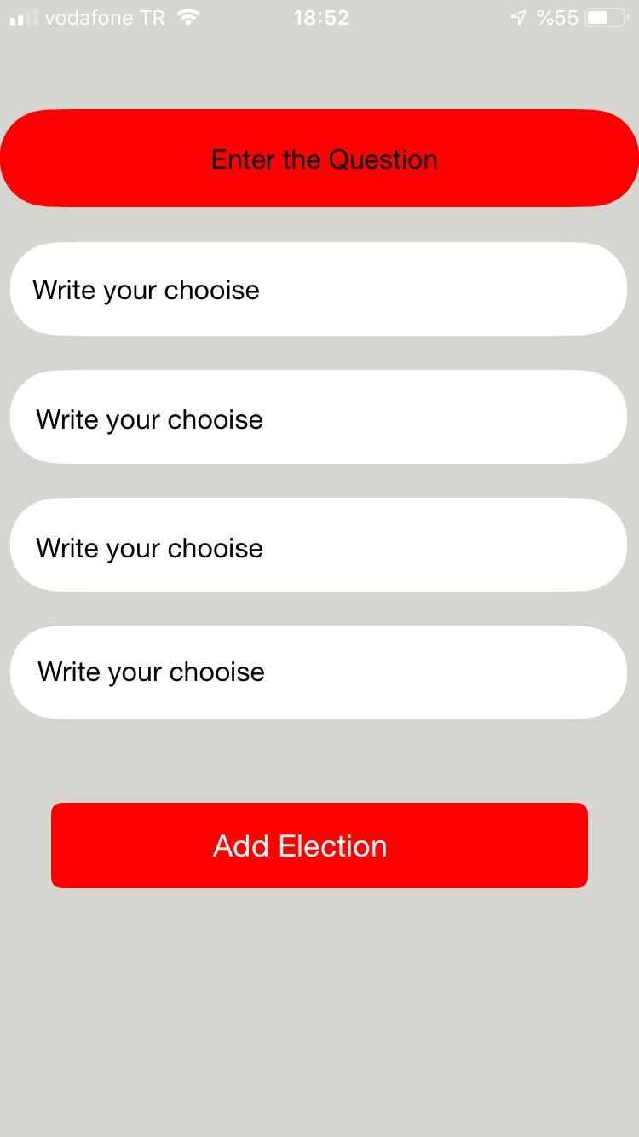

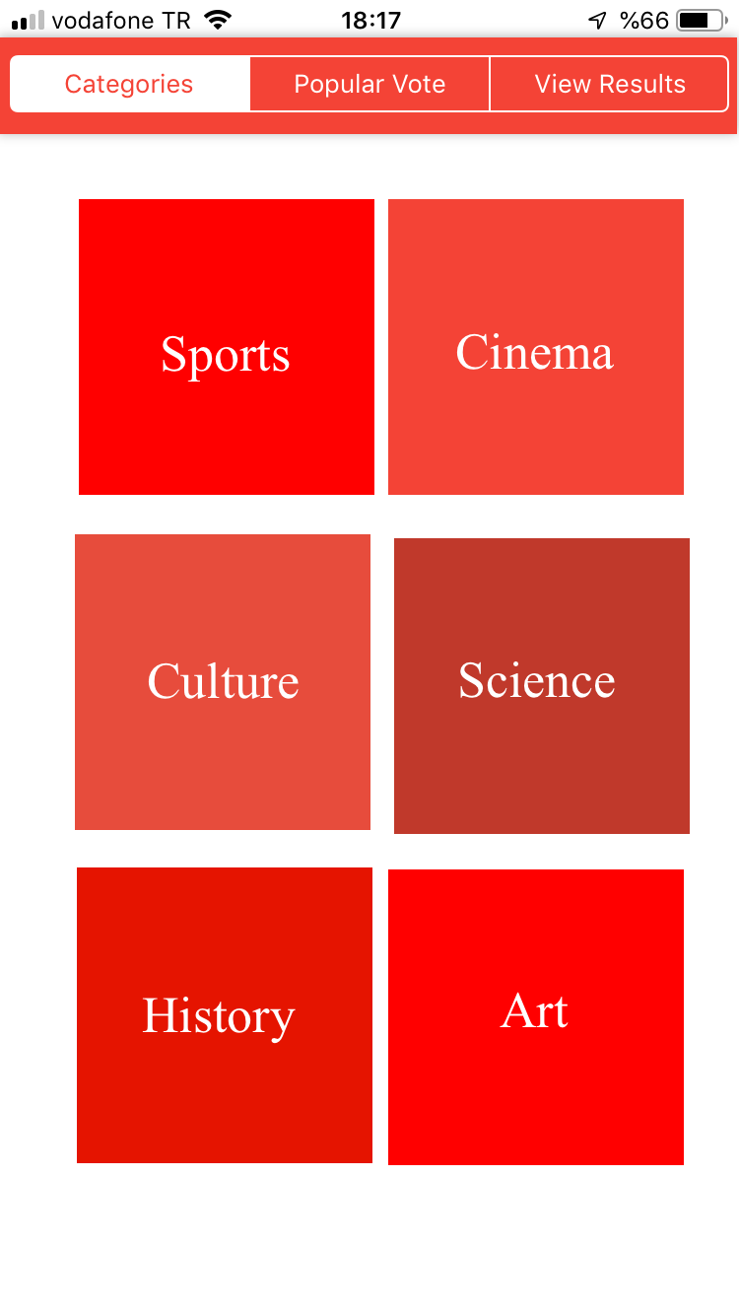

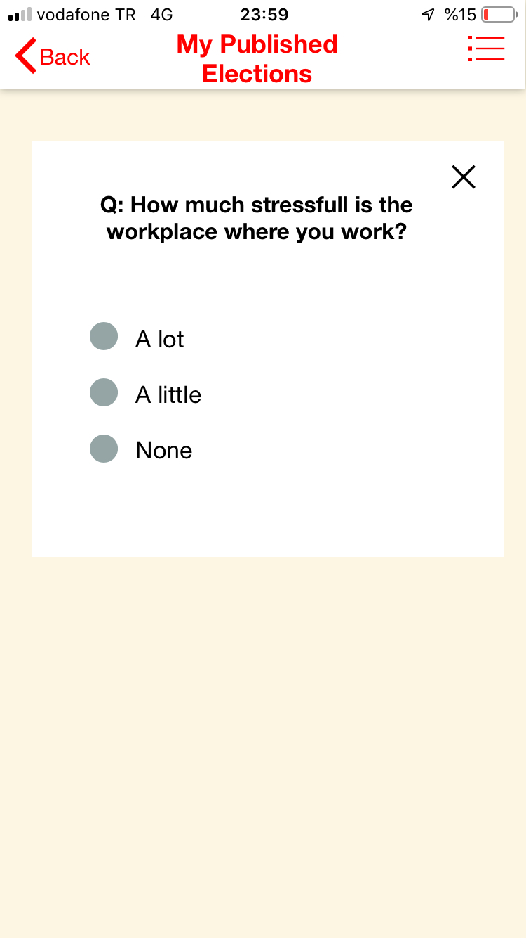

**Scenario 7:**

**Scenario name: Freeze My Account**

**User Name: Santi**

**Participant actor instances: Registered User**

The flow of events:

1. Santi wants to freeze own account.
2. Santi opens application and logs-in to system.
3. Santi clicks to profile button.
4. Santi views own profile and information.
5. Santi clicks freeze my account button.
6. Santi takes a notification and he will be log out automatically.

**USE CASE 7:**

|  |
| --- |
| Use Case Name: Freeze My Account |
| Participant Actor: Registered user |
| Flow of Events:  1. Registered user opens the application and log-in to the system.  2. Registered user clicks the profile button and views own profile.  3. Registered user clicks the freeze my account button. |
| Entry Condition:  1. Registered user must log-in to system. |
| Exit Condition:   1. Registered user can freeze own account successfully AND,   Registered user logged out automatically. |